

**POWER BI**

**PROJECT FILE**

**SESSION: 2024-2025**

**MBA**

**SUBMITTED TO: DR. SOURABH POSWAL**

**SUBMITTED BY: HARSH SETHI [CU240140532]**

**YASH GUPTA [CU240140530]**

**MAYANK RAWAT**

**OBJECTIVE OF THE DATA**

**The objective of a sales report for a firm is to provide a comprehensive analysis of the company's sales performance over a specific period. This report serves multiple purposes for management, stakeholders, and decision-makers. Below are the key objectives of a sales report:**

**1. Track Sales Performance**

* **Measure success: The primary objective is to assess how well the firm is performing in terms of sales, comparing actual sales against targets, previous periods, or forecasts.**
* **Identify trends: Identify upward or downward trends in sales performance to understand seasonality or market changes.**

**2. Monitor Revenue Generation**

* **Revenue analysis: Track total revenue generated from sales, helping to evaluate the financial health of the firm.**
* **Profitability: By including profit data, it can also measure the firm's profitability and highlight areas where margins may need improvement.**

**3. Assess the Effectiveness of Sales Strategies**

* **Sales strategies review: Analyze the impact of marketing campaigns, sales tactics, or promotions on overall sales.**
* **Sales channels: Evaluate the effectiveness of different sales channels, such as online, retail, wholesale, etc.**

**4. Customer Insights**

* **Segmentation: Understand customer behavior, preferences, and demographics by segmenting sales data (e.g., by region, customer type, product category).**
* **Customer performance: Identify top customers, repeat customers, and high-value segments.**

**5. Inventory Management and Forecasting**

* **Stock requirements: Help in predicting demand and managing inventory levels based on sales trends, preventing stockouts or overstocking.**
* **Forecasting: Use historical sales data to forecast future sales, enabling better planning and resource allocation.**

**6. Financial Planning and Budgeting**

* **Revenue forecasting: Accurate sales reports allow for better financial planning, helping to set realistic budgets and forecasts for the upcoming periods.**
* **Cost analysis: Analyze costs associated with sales efforts (e.g., discounts, marketing spend) to ensure profitability.**

**7. Sales Team Performance Evaluation**

* **Individual and team performance: Evaluate the performance of the sales team, assessing their contribution to overall sales and identifying areas for improvement.**
* **Incentive programs: Provide data to determine incentives or commissions for sales personnel based on their performance.**

**8. Decision Support for Leadership**

* **Informed decisions: Provide management with accurate, up-to-date sales data, enabling data-driven decisions regarding product launches, market entry, or sales force changes.**
* **Strategic planning: Sales reports support long-term strategic planning by offering insights into customer trends, market opportunities, and areas requiring attention.**

**9. Competitive Analysis**

* **Market positioning: Comparing sales performance against industry benchmarks or competitors (if available) helps assess the firm’s market position and competitiveness.**
* **Product and market adjustments: Identify areas where the firm can improve or adapt to match or exceed competitor offerings.**

**10. Regulatory and Stakeholder Reporting**

* **Compliance: Ensure the firm complies with reporting standards and tax regulations by providing required sales data.**
* **Stakeholder communication: Share sales performance with investors, shareholders, and other stakeholders to ensure transparency and build trust.**

**In Summary:**

**The objective of a sales report is to provide insights into sales performance, guide decision-making, ensure strategic alignment, and drive profitability and growth. It serves as a tool for tracking progress, evaluating strategies, and identifying opportunities for optimization across the firm’s sales and marketing efforts.**

**DETAILED REPORT ANALYSIS**

**Step 1: Importing the Data**

1. **Open Power BI Desktop**.
2. **Click on "Get Data"** on the Home tab, and choose **Excel**.
3. **Select the file** containing the sales data and load it into Power BI.
   * In the Navigator, select the table or worksheet containing the sales information.
   * Click **Load**.

**Step 2: Data Transformation (Optional but Recommended)**

You can clean and transform the data in Power Query Editor to ensure it is well-structured for analysis.

* **Change column types**: Ensure columns like **Order Date**, **Ship Date**, **Sales**, **Profit**, **Quantity**, etc., are correctly set as date, numeric, or text types.
* **Fix missing or null values**: Handle any missing data appropriately (you can remove or fill null values as needed).
* **Create Date Table**: If you want to perform time-based analysis, create a date table for time intelligence functions.

Once done, click **Close & Load** to return the data into Power BI.

**Step 3: Create Key Visualizations**

**1. Sales Performance (KPIs)**

* **Total Sales**: A KPI that shows the sum of the **Sales** column.
  + Use a **Card** visualization.
  + Drag the **Sales** field into the "Values" field well.
  + This will show the total sales amount for the entire dataset.
* **Total Profit**: A KPI for showing the total **Profit**.
  + Use another **Card** visualization.
  + Drag the **Profit** field into the "Values" field well.
* **Total Quantity Sold**: A KPI for showing the total number of **Quantity** sold.
  + Use a **Card** visualization.
  + Drag the **Quantity** field into the "Values" field well.

**2. Sales Over Time (Trends)**

* **Line Chart**: To visualize **Sales** over time.
  + **Axis**: Use **Order Date**.
  + **Values**: Use **Sales**.
  + You can drill down by month, quarter, or year to view sales trends over different time periods.

**3. Sales by Region**

* **Bar Chart**: To visualize total sales by **Country/Region** or **State**.
  + **Axis**: Use **Country/Region** or **State**.
  + **Values**: Use **Sales**.
  + This helps you identify which regions are performing the best in terms of sales.

**4. Sales by Category & Sub-Category**

* **Stacked Column Chart**: To show **Sales** by **Category** and **Sub-Category**.
  + **Axis**: Use **Category**.
  + **Legend**: Use **Sub-Category**.
  + **Values**: Use **Sales**.
  + This chart helps analyze how different categories and sub-categories contribute to overall sales.

**5. Profitability by Product**

* **Scatter Plot**: To analyze profitability for each product.
  + **X-axis**: Use **Sales**.
  + **Y-axis**: Use **Profit**.
  + **Details**: Use **Product Name**.
  + This visualization helps you understand which products are contributing to sales and profitability, and which products might need attention due to low profit margins.

**6. Sales by Ship Mode**

* **Pie Chart** or **Donut Chart**: To show the percentage distribution of sales by **Ship Mode** (e.g., Standard Class, Second Class).
  + **Values**: Use **Sales**.
  + **Legend**: Use **Ship Mode**.
  + This will give you an idea of how different shipping methods impact total sales.

**7. Discount Impact on Sales and Profit**

* **Clustered Bar Chart**: To show the impact of **Discount** on **Sales** and **Profit**.
  + **Axis**: Use **Discount**.
  + **Values**: Sum of **Sales** and **Profit**.
  + This chart will help you understand whether higher discounts lead to higher or lower profit margins.

**8. Top Customers by Sales**

* **Table** or **Bar Chart**: To show the top customers based on **Sales**.
  + **Customer Name** as rows.
  + **Sales** as values.
  + You can use a filter to display only the top N customers based on sales performance.

**Step 4: Adding Interactivity with Slicers**

* **Slicer for Date**: Use a **Date Slicer** to filter the report by year, quarter, month, etc.
  + Drag the **Order Date** field to the slicer visual.
* **Slicer for Segment**: Use a slicer to allow filtering by **Customer Segment** (e.g., Consumer, Corporate, Home Office).
* **Slicer for Region/State**: Use a slicer to filter by **Country/Region** or **State**.
* **Slicer for Category/Sub-Category**: To filter visualizations by product **Category** and **Sub-Category**.

These slicers will allow users to interactively filter and drill down into specific parts of the dataset.

**Step 5: Formatting the Report**

* **Titles and Labels**: Add titles for each visualization (e.g., "Sales by Region", "Top Customers").
* **Formatting the Visuals**: Adjust colors, labels, and font sizes to make the report visually appealing and easy to interpret.
* **Tooltips**: Add tooltips to provide additional information when users hover over elements (e.g., showing sales details when hovering over a bar in a chart).

You can also apply a theme to ensure the report has consistent colors across all visuals.

**Step 6: Publish and Share the Report**

Once the report is complete, save it as a Power BI file (.pbix). If you want to share the report:

* **Publish to Power BI Service**: Click on the "Publish" button in Power BI Desktop to upload your report to the Power BI Service for sharing.
* **Export to PDF**: If you need a static report, you can export the entire report as a PDF.
* **Share with Stakeholders**: Share the link to the report with relevant stakeholders or embed it on your website.

**Sample Report Layout and Visuals**

* **KPIs**:
  + Total Sales: $X million
  + Total Profit: $Y million
  + Total Quantity Sold: Z units
* **Sales Trend**: Line chart showing sales over the last 12 months.
* **Sales by Region**: Bar chart showing sales by country/region.
* **Sales by Category & Sub-Category**: Stacked column chart with categories and sub-categories.
* **Profitability by Product**: Scatter plot comparing sales and profit for each product.
* **Top Customers by Sales**: Table listing the top customers by sales volume.
* **Discount Impact**: Clustered bar chart comparing the sales and profit for different discount percentages.

**Conclusion**

With this Power BI report, you will be able to analyze and visualize the sales performance across different dimensions (time, region, category, etc.). The report will provide valuable insights into the effectiveness of various sales strategies, product profitability, and customer behavior, helping the firm make data-driven decisions to improve sales performance and profitability.

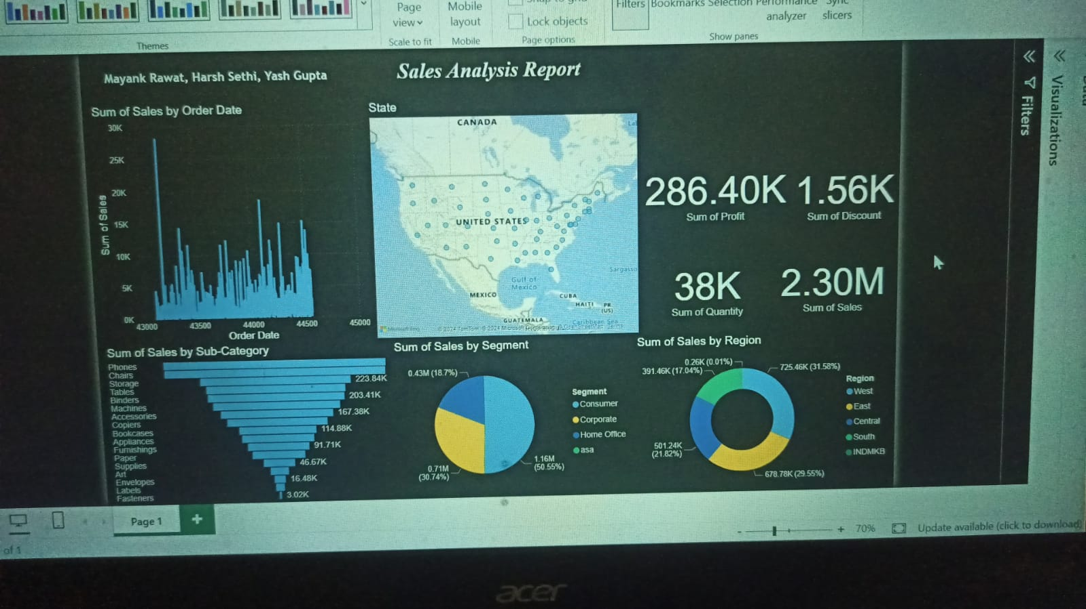

**FOLLOW UP QUESTIONS**

**1. Sales Performance and Profitability**

* **Are there any noticeable trends or patterns in the sales data?**
  + For example, is there a peak season where sales increase, or are there certain months with consistently low sales?
* **Which regions or states have the highest and lowest sales?**
  + Can we identify specific reasons for these discrepancies, like market saturation or economic conditions?

**2. Sales Trends Over Time**

* **What is the year-over-year (YoY) sales growth?**
  + Is there a significant increase or decrease in sales, and can we correlate this to changes in strategy or external factors?
* **How do sales perform across different time periods?**
  + Are there any seasonal variations or monthly fluctuations that we can capitalize on?

**3. Customer Insights**

* **Which customer segments are generating the most sales and profit?**
  + Are there specific segments (e.g., Consumer, Corporate, Home Office) that are more profitable, and should the company target them more aggressively?
* **Who are the top 10 customers contributing to the highest sales?**
  + Are these long-term customers, or are they part of a recent growth surge? Should we look into customer retention strategies?

**4. Sales Strategy and Discounts**

* **What is the impact of discounts on sales and profitability?**
  + Are larger discounts leading to higher sales, but at the cost of profit margin?
* **Does offering a discount on specific products or categories lead to an increase in overall sales?**
  + Are there products where discounts have a bigger impact on sales volumes, and can we optimize pricing for them?

**5. Sales by Ship Mode and Delivery Insights**

* **Which ship modes (e.g., Standard Class, Second Class) contribute to the most sales?**
  + Does the type of shipping affect the timing or customer satisfaction of the sale?
* **What is the correlation between shipping method and delivery time on sales performance?**
  + Should the firm focus more on faster shipping methods to improve customer satisfaction and retention?

**Additional Follow-up Considerations:**

* **Report Customization**: Are there specific stakeholders (e.g., sales team, marketing team, executives) who need customized views or dashboards?
* **Report Automation**: Can this report be automated for regular updates, or should it be generated monthly/quarterly for continuous performance tracking?

These follow-up questions are essential for making the report more actionable, ensuring the business can continuously optimize sales strategies, improve profitability, and provide a more granular understanding of its sales data.